Implement program for decomposing time series data into trend and seasonality
EX:No.7
DATE: 08/03/25

Implement program for decomposing time series data into trend and seasonality

DATE: 08/03/25

AIM:
To implement a program for decomposing time series data into its trend, seasonal, and residual components.

OBJECTIVE:
To analyze and understand the underlying structure of the Office Supply Sales time series data by breaking it down into trend and seasonality components using decomposition techniques.

BACKGROUND:
- Time series data often contains patterns that repeat over time.
- Decomposition helps in separating these components for better analysis and forecasting.
- Trend shows long-term progression.
- Seasonality captures periodic fluctuations.
- Residual reveals random noise not explained by trend or seasonality.
- Understanding these components helps improve model accuracy and insights.

SCOPEOFTHEPROGRAM:

•Load and prepare the office supply sales dataset.
•Aggregate data monthly for decomposition.
•Apply time series decomposition using additive model.
•Visualize and interpret the trend, seasonal, and residual components.

ALGORITHM:

- Import required libraries.
- Load the cleaned sales dataset.
- Resample the data monthly to make it suitable for decomposition.
- Use the seasonal_decompose() function to perform additive decomposition.
- Plot the original series, trend, seasonality, and residual components

CODE:

import pandas as pd
import matplotlib.pyplot as plt
from statsmodels.tsa.seasonal import seasonal_decompose

# Load the AirPassengers dataset
df = pd.read_csv("/mnt/data/AirPassengers.csv")

# Display the first few rows to check column names
print(df.head())

# Convert 'Month' column to datetime format
df['Month'] = pd.to_datetime(df['Month'], format='%Y-%m')

# Set 'Month' as the index
df.set_index('Month', inplace=True)

# Rename the passenger column if needed
df.rename(columns={df.columns[0]: 'Passengers'}, inplace=True)

# Ensure there are no missing values
df.dropna(inplace=True)

# Decompose the series
decomposition = seasonal_decompose(df['Passengers'], model='multiplicative') # 'additive' also works depending on trend

# Plot the decomposition
plt.figure(figsize=(12, 8))
decomposition.plot()
plt.suptitle("Time Series Decomposition of Monthly Air Passengers", fontsize=16)
plt.tight_layout()
plt.show()

OUTPUT:

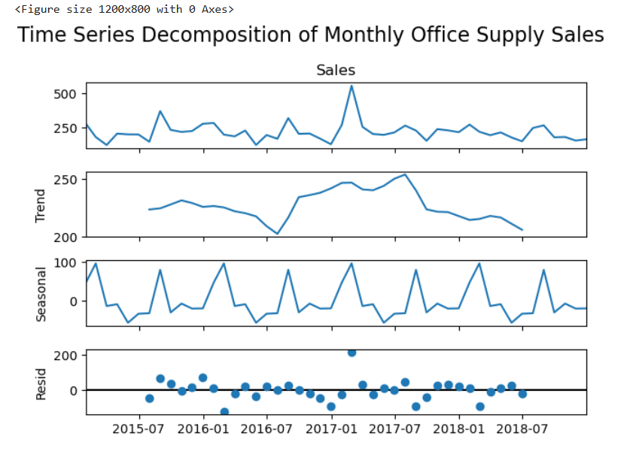

RESULT:
Thus,theprogramfor decomposing time series data into its trend, seasonal, and residual componentshasbeendone successfully.

